Project Closure Report

March 10, 2019
Trim, Improve and Sustain Natural Forests in Sarsink Area
- : www.nujeen.org  : info@nujeen.org | : 009647507621055  Kurdistan, Duhok, 86 Sargash Street, Malta Quarter | 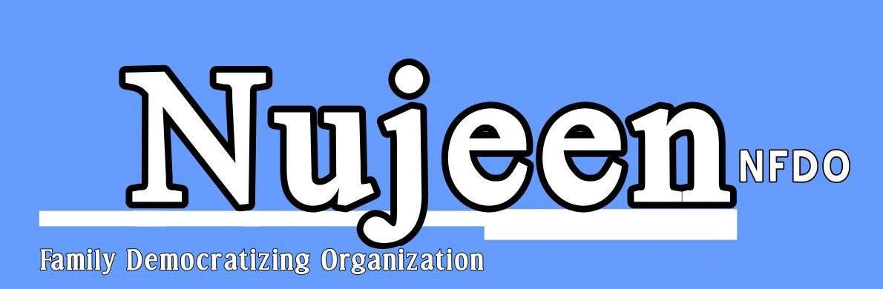

Nujeen for Family Democratizing Organization (NFDO)

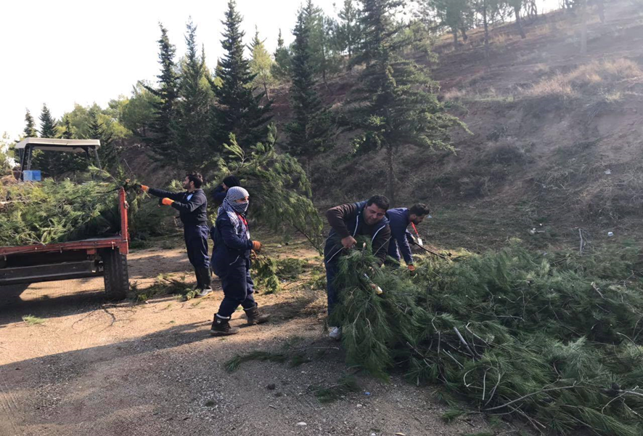

Table of Contents
Introduction 3
Project description 4
Project summary 4
Project objectives 5
Project achievements 5
Project activities 6
Beneficiaries registration process 6
Selection criteria and procedure 6
Opening ceremony 7
Opening a one practical training and an awareness session 8
Project implementation 9
Project challenges 9
Monitoring and evaluation 10
Lessons learnt 10
Appendix I 11
Appendix II 17
Contact information 18

Introduction

Nujeen for Family Democratizing Organization (NFDO) was established in September 2003, approved by the Kurdistan Regional Government and the Federal Government of Iraq.
The strategic objective of the organization is to organize family relations and other community relations based on democracy, participation and pluralism, activate the peace process in the region and resolve conflicts peacefully. It also has branch offices in both Sharia complex and Domiz1 camp, and they serve as social centers.
Because (NFDO) concerns about family and its mission is spreading a democratic and a humanitarian culture among family and society members, thus, it is obvious that the target groups are youth, women, persons with special needs and children.
Accordingly, the organization has six strategic objectives in the social, economic, cultural, political, legal and educational sectors to lead us to achieve the vision and mission of the organization in creating a democratic civil society. Since its establishment, the organization has entered into alliances and networks with international and local organizations. Throughout this period, Nujeen has implemented dozens of projects in different sectors of work, as well as with various national and international partners and donors, particularly in CfW sector and has previous experience with GIZ.

The most important donors that have financially supported our projects so far;
- GIZ
- Handicap International HI,
- European Union (EU)
- Concern World Wide
- Safe Abortion Action Fund (SAAF)
- Many of the UN agencies like UNICEF, UN-WOMAN, UNDP, and UNFPA.

Project description
NFDO has started implementing a cash for work project of (Trim, improve and sustain natural forests in Sarsink area) that supported by GIZ. The aim of the project was to preserve, protect and improve natural environment through the organized revitalizing, revive and renewable cutting or trimming of about (14,400) trees on a land of (250) acres of natural woods located between Sarsink sub district and Ashawa resort.
On the other hand, the financial status of the project area residents is not high enough, so the main objective is income creation for the vulnerable households from the host community, besides access to income for women and persons with disabilities.
It was a teamwork for (60) working days, by members of (68) vulnerable families as direct beneficiaries including males, females and PwDs from the project area and surroundings and 23,400 indirect beneficiaries.
The impacts of the project on the community are eliminating pollution by increasing and strengthening green zone area, safe the forest from the fire and make the natural forest to beautify the area. Also providing a source of income, as it will attract tourists.

Project Summary
Project title | Trim, improve and sustain natural forests in Sarsink area
Project duration | 4 months as planned, with the extension of one more month  (September 23, 2018 to January 22, 2019) extended to Feb 22, 2019
Location | Sarsink sub-district and Ashawa resort
Project budget | EUR 103,723,78
Target group | Most vulnerable and poor residents from host community of the project area
Number of direct beneficiaries | - direct beneficiaries  - (24 females+ 38 males+ 6 PwD)  - (8) skilled laborers ( 2 supervisors)  - 60 unskilled laborers
Number of working days | 60 working days per beneficiary

Project objectives
- The project was designed to be a mean for income creation to the most vulnerable households from host community, due to the shortage of working opportunities in the area.
- Revive cutting of 14,400 trees on a land of 250 acres of natural woods and the forest from the weeds and unwanted shrubs.
- Involving women and disabled persons in the community activities for income creation.
- Generating a temporary job for the vulnerable families, as a mechanism to reduce poverty and provide basic needs for their families.
- Providing required care for the natural forest to enhance the sight.
- Reducing the atmosphere pollution.
- Increasing prevention of the fire risks.
- Cleaning the forest from the weeds and unwanted shrubs.

Project achievements
- Relationships created between the individuals from different backgrounds
- Income creation for many needy families
- Strengthening social relations without considering ethnic, gender or religion.
- Cleaning, cutting and reviving more than targeted area.
- Involving women and persons with special needs in the project implementation, and considering all of them alike.
- Keeping the beneficiaries on work and boosting their mood and motivation not to stop working as well as preventing them from complaining about the organization publicly, due to the delay in the payments.
- Not having serious accidents, injuries or burns among the workers.
- Paying 10 days of the workers’ wages from Nujeen budget line to promote the work.

Project activities
Beneficiaries’ registration process
On October 7, 2018 was the first day of preparation for beneficiaries’ registration, the team that was committed to do so has been trained on filling the forms and interviewing the applicants. The following days, were arranged for conducting meetings with the directorate of woods and forest-Sarsink, the mayor of Sarsink, directorate of the environmental conservation and the Mukhtars and leaders of 6 villages from the area; including (Sikrine, Badaresh, Azadi, Sarsink, Qadish and Ashawa). Around 200 people, including females and PwD filled the forms and did interviews.

Selection criteria and procedure
After the registration process of the applicants had completed, the selection procedure had followed and was according to some criteria. The form consisted of several enquiries and each was rated a mark. Whoever had a higher range of points, meant that the person is highly in need and would be accepted in the project. The difficulties that the project team was faced were the selecting appropriate candidates, since there were a huge number of the applicants and the pressure on the staff to accept themselves or their relatives. Fortunately, the staff was able to overcome the challenged obstacles and select the most needy and vulnerable applicants depending on the criteria of the form, including 60 unskilled laborers and 6 skilled beneficiaries along with 2 supervisors. As expected although many women have registered themselves at the beginning, but then due to some family issues they were unable to work in the project. Two of them have withdrew in the very start of the project then been replaced by two of the other needy women and worked throughout the project implementation to the end.

In addition to taking into consideration the participants of the different ethnicities and religions to be participated in the project implementation.
The selection of the 68 workers was based on several sources of information provided by relevant stakeholders, local authorities and according to their points for each criteria by the team. The objective of the mentioned criteria of selecting PwDs, being poor, not so poor and vulnerable People, who are capable of working. As one of the aims of the project is to involve this group of people in working and activate them within the community.

Basic criteria

Basic Criteria for Eligible Beneficiaries

Some Questions |  | Score
 |  | 10 | 8 | 5 | 3 | 0
Who is heading the household? | Female | (6 or more) | (4-5) | (up to 3) | ……………. | …………..
 | Male | ....................... | ......................... | (6 or more) | (4 to 5) | ( up to 3)
How many members are there in the family? |  | 8 or more | 6-7 | 4-5 | 3 | Up to 2
No. of family members below 6 years old? |  | 4 or more | 3 | 2 | 1 | 0
Are you disabled? |  | Yes | ………. | ………. | ……… | No
How many persons are working the family? |  | ………… | …………. | 0 | 1 | 2 or more
Type of housing? |  | unfinished building | Rented house | Tent | Shared house | Owner
No. of family members who are chronically ill or disabled? |  | 2 or more | 1 | ………… | ………… | 0
No. of family member above 63 years old? |  | 3 or more | 2 | 1 | …………. | 0

Opening Ceremony
The opening day of the cash for work project under the title (Trim, improve and sustain natural forest in Sarsink area) has been held in Badarash hall-Sarsink, on Nov 14, 2018. It was being attended by the director of woods and forest in Sarsink, director of environmental preservation force-Duhok and a GIZ representative Miss. Hero Butan, along with many other local representatives from the area, and some TV channels like WAAR TV, Kurdistan TV, Kurdistan24 TV, and VoA. The event started with a speech by Nujeen director Mr. Abdal A. Abdal explaining the aims, reasons and outcomes of the project, followed by a speech of the director of environmental preservation force-Duhok for applauding and describing the positive impacts of the project.

Opening a one day practical training and an awareness session
Holding a one day practical training on occupational safety for the beneficiaries by an expert Mr. Ali Qasim director of woods and forest-Sarsink, in order to gain work skills and how to use tools properly, since some tools were harmful and required refined practice.
Following by the awareness session on basic principles of first aid and the need for a box of aid every working day by a professional doctor Fakhir Muhammad Salih. The aim was to spread environmental awareness and provide safety guidelines, definition of tasks and responsibilities, after that, the protective equipment and clothes were distributed among the workers.

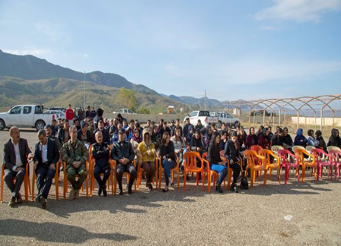
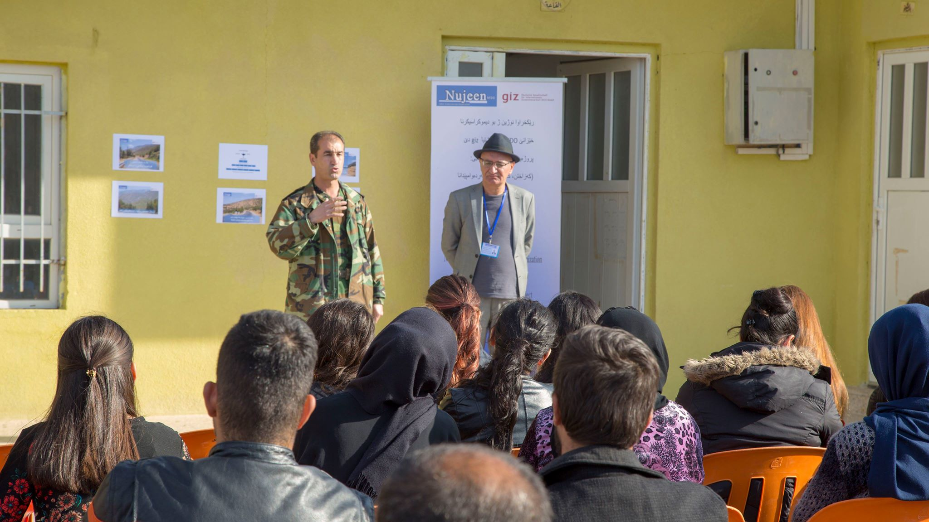
Opening ceremony day, gathering beneficiaries for beginning the trainings A speech by the director of environmental preservation force-Duhok
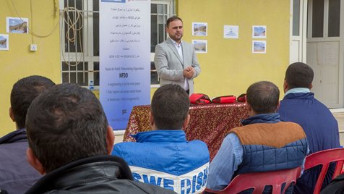
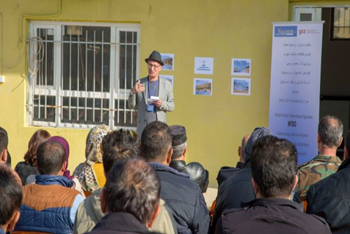
NFDO speech by the executive director Mr. Abdal Dr. Fakhir Muhammad Salih is giving his training on the basic principles of first aid
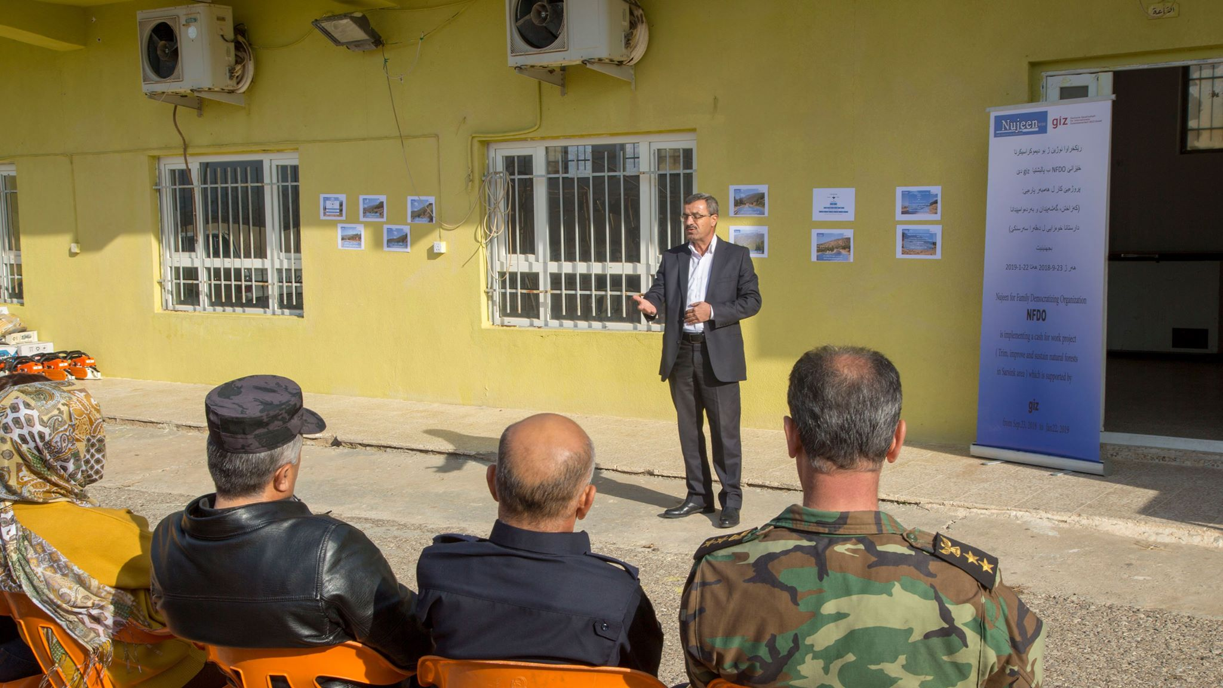

Giving an occupational safety training by the engineer Ali Qasim

Project Implementation
The first day of the project implementation by the beneficiaries started on Nov 14, 2018, the workers were divided into 6 groups; each group consisted of a skilled laborer followed by 10 unskilled workers and (2) supervisors for all that supervised and controlled over all groups with giving required instructions. The working hours started from 8:00am to 2:00pm. The workers begun pruning, trimming dead or overgrown tree branches and cleaning the targeted area to encourage growth and sustain trees’ health. Furthermore, some posters and banners have been published in order to preserve natural forests and raise awareness of occupational safety.
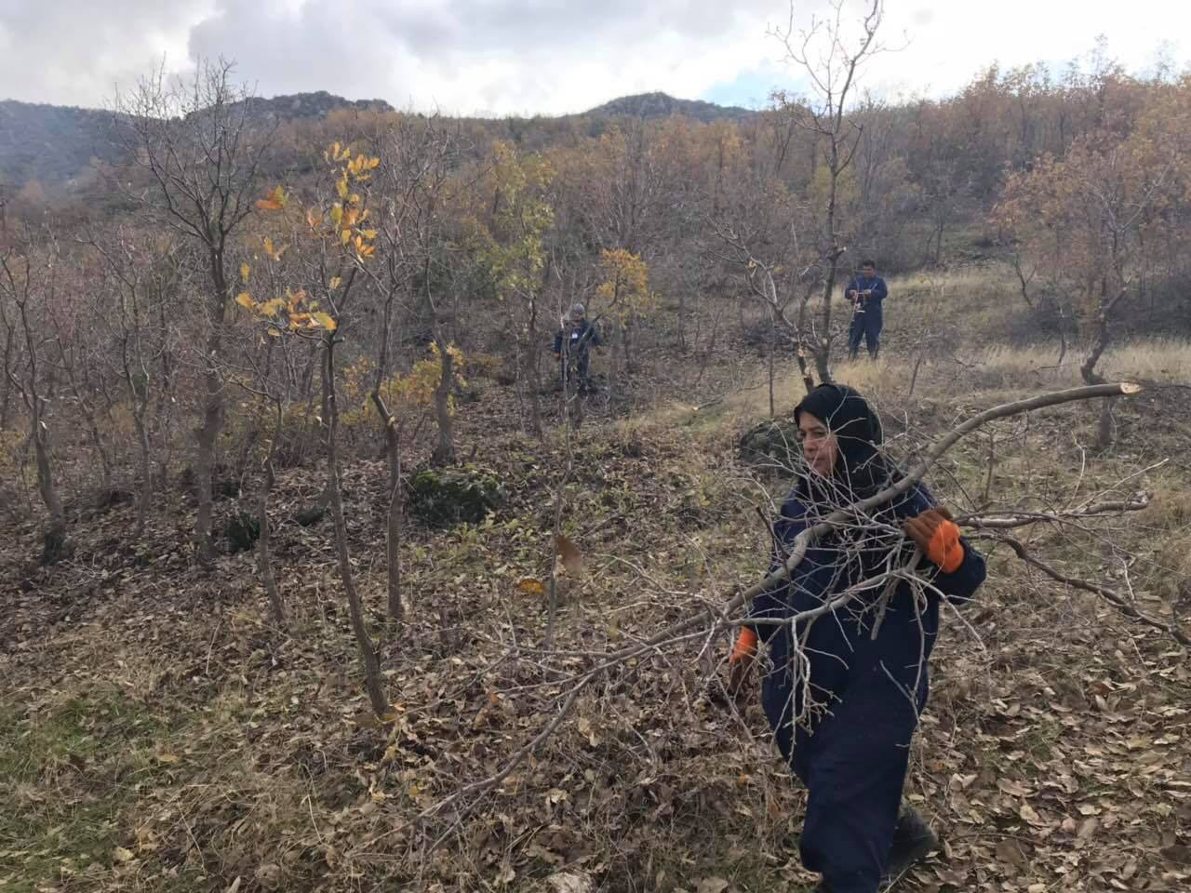
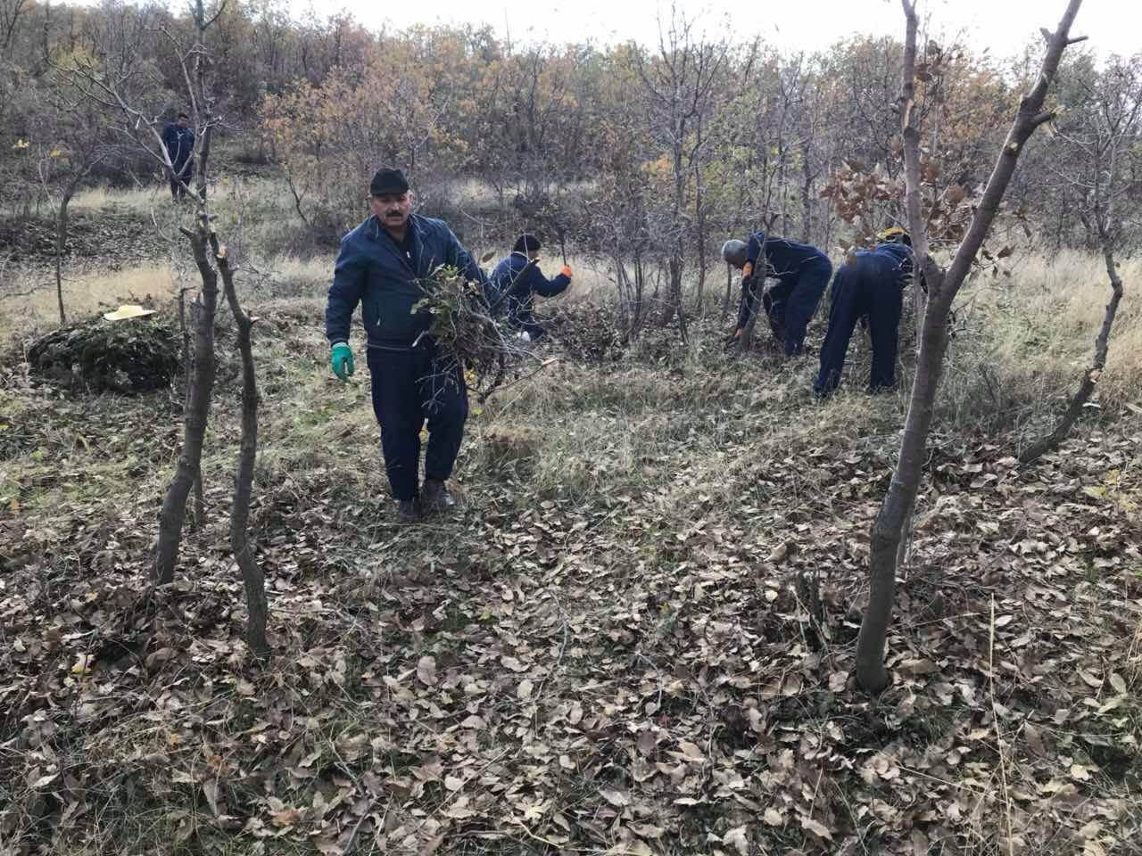
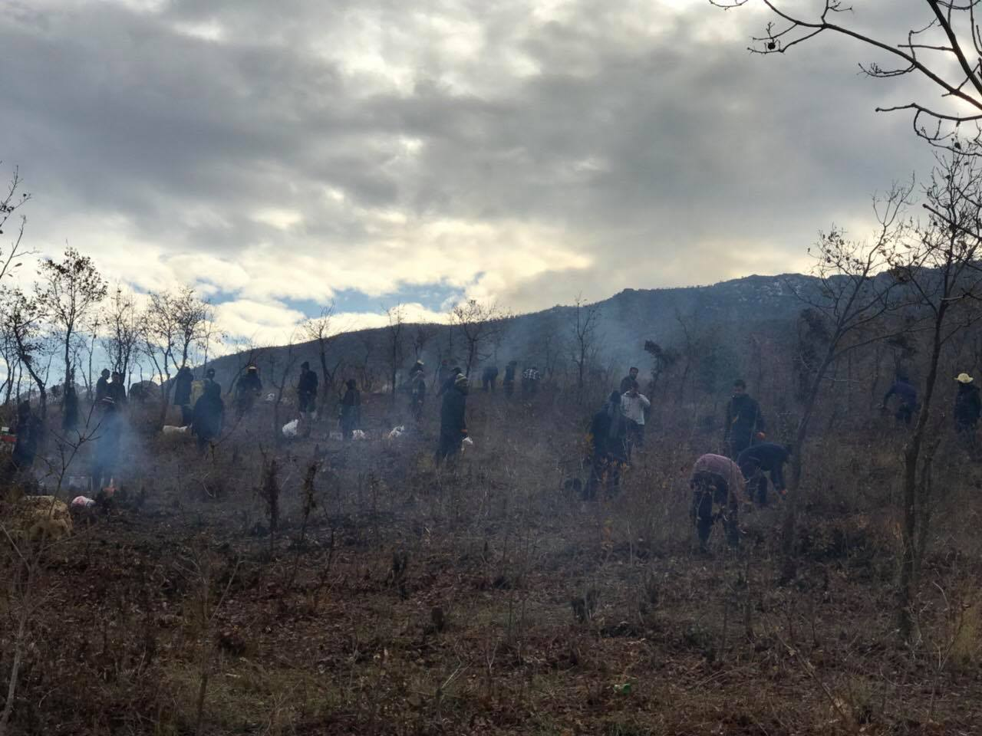
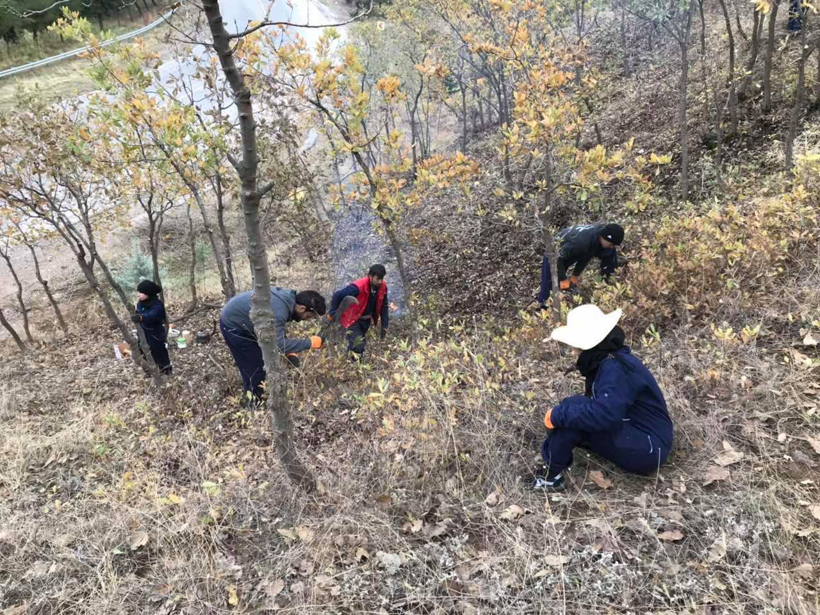

The beneficiaries’ work including women during the project implementation

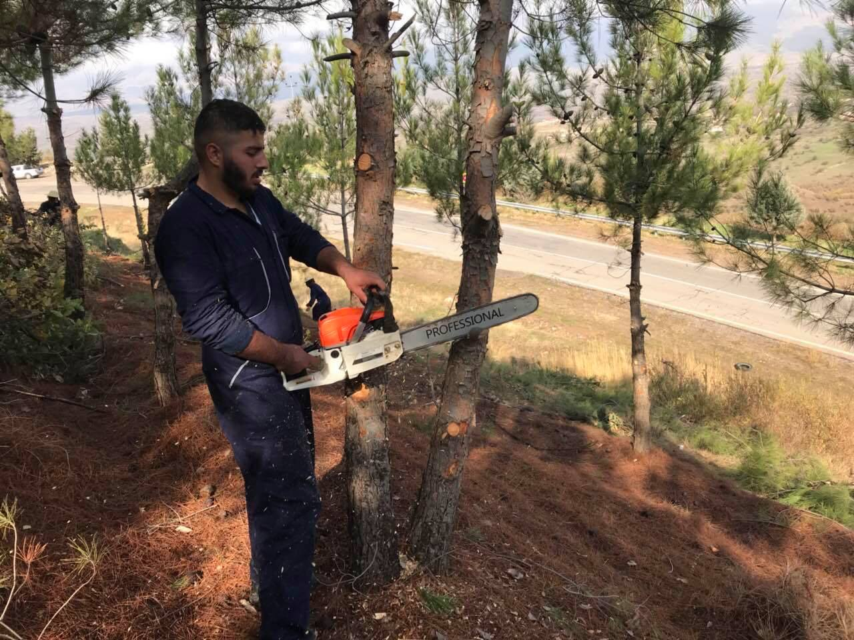

A worker is cutting the trees with a saw
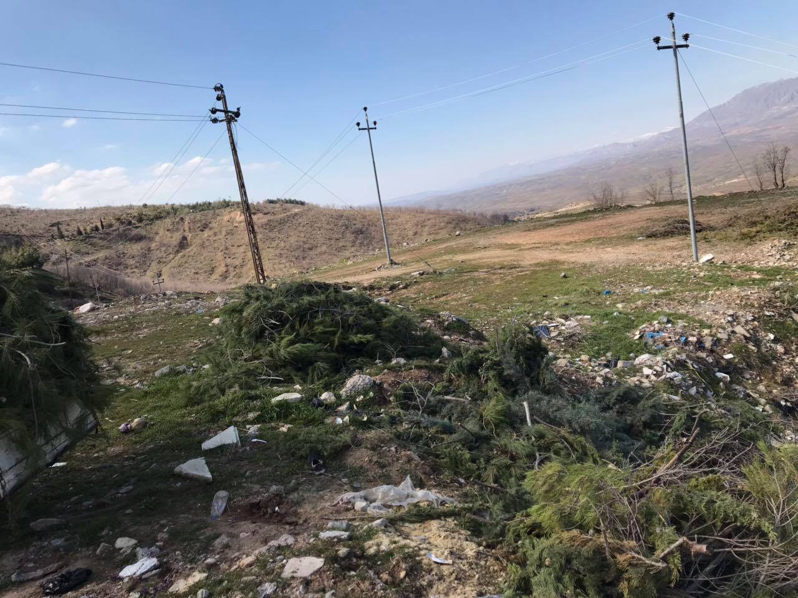

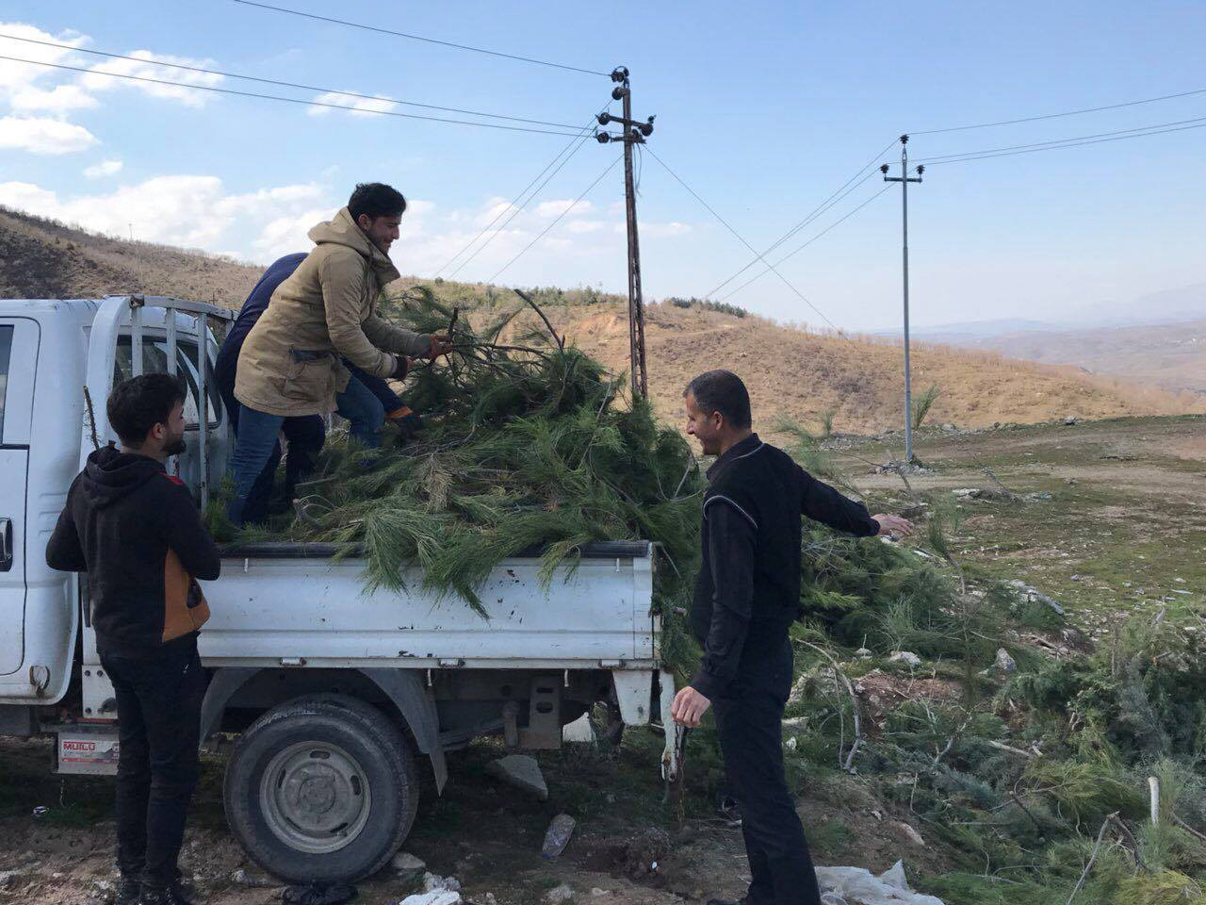
The last days of the project when the trash was collected in a place to clean the place

Finally, the rubbish was taken to the target place

Project challenges
Challenges | Actions taken
The difficulity in women participation and persuation for filling the forms. | Registered and accepted 24 women, gave priority to them
The need for detail explanation of the questionnaires, due to their literacy inability, which took more time for the process. | Conducted a team of two members; a male and a female for questionnaires explanation
Lack of support from Mukhtars and community leaders of the area in finding and persuading women for registerion. | Reached to the needy women by their relatives and neighbors
Non-cooperation of the women’s families in allowing them to come to work, because of the cultural and traditional beliefs. | We convinced their families that there are some more women in the field as well as it will be a source of income for the family
The severe weather conditions that stopped them from regular working | Postponed the work for other days, which the weather was sunny or cloudy
Delay in the transferring first disbursement that led to the delay in the beneficiaries’ payments. | Payed their wages of 10 days from Nujeen’s budget line
Not completing work according to the project deadline | Extended one more month to finish the work due to the snow and heavy weather

Monitoring and Evaluation
The process of checking absentees was done according to the GIZ system of MEDI for having accurate result of the attendances and absentees, while the attendance hard sheet was prepared and used with date and workers’ signature for taking daily attendance. This attendance checking process was significant for paying workers’ wages.
This helps to find out whether the workers have received their daily wages correctly according to their working days. The monitor and supervisors were updating the activities and confirming that they were going according to their planned schedule, as well as evaluating the work quality and progress.

Lessons learnt
However, the project has accomplished successfully and effectively, since it created a positive relationship between the participated community members and encouraged teamwork of the mixed groups. The participation of women and PwD was one of the strong and excellent points of the project success, although the women of the project are restricted to the social and traditional roots and beliefs for not working outside and mainly with men as a team. Thus for plans and project implementations in the future, the participation of women should be mandatory. As well as, the beneficiaries should be from the project area itself, because having workers from other districts far from it would end up in transportation issues.

Appendix I:
The support document from the directorate of woods and forest-Sarsink.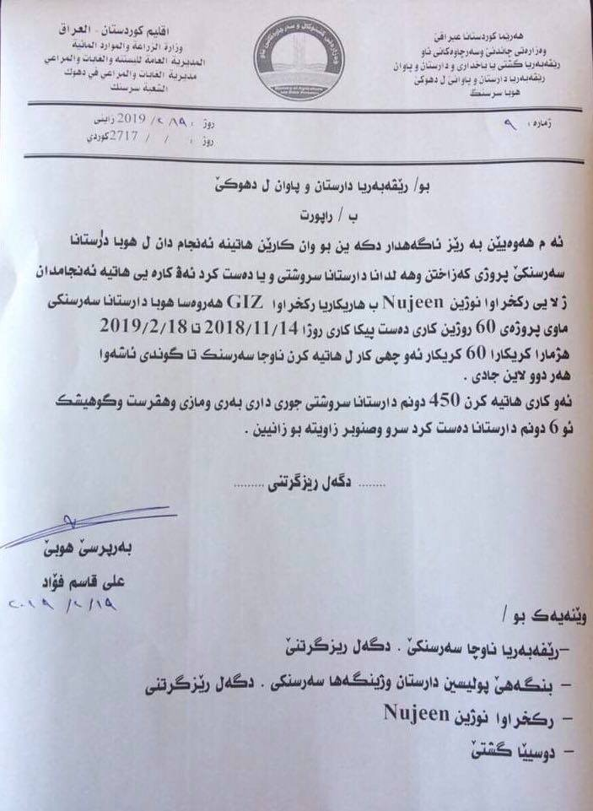

Appendix II:
The appreciation letter of the general director of Sarsink district
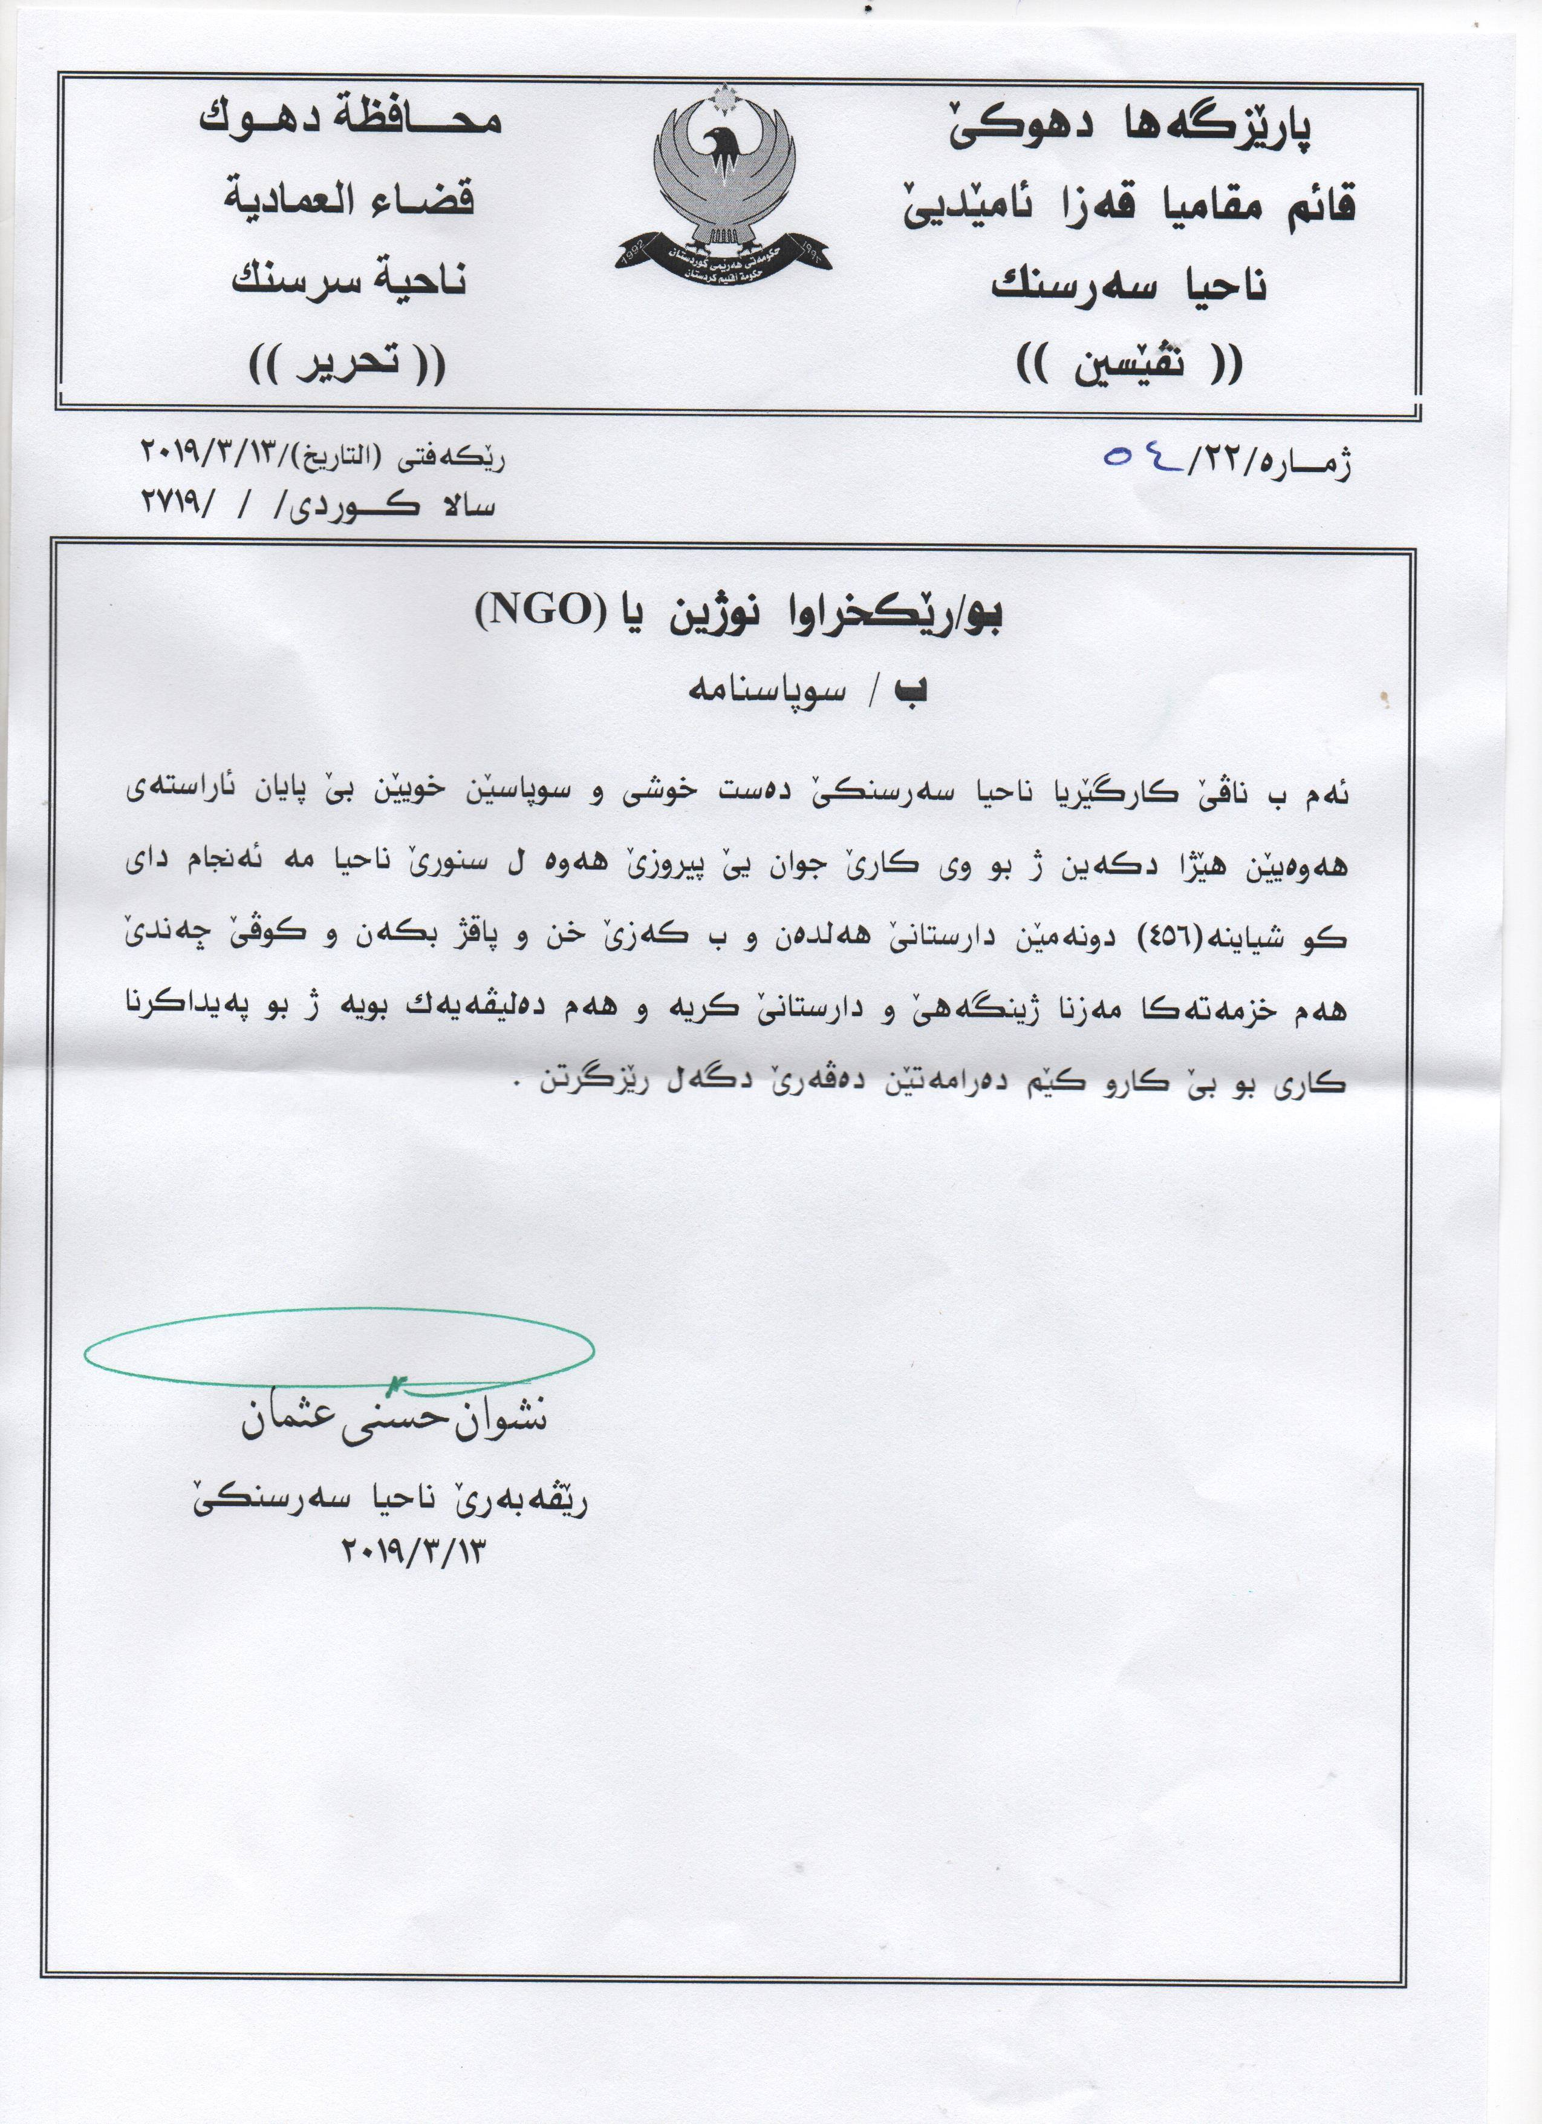

Appendix III:
The samples of the printed posters
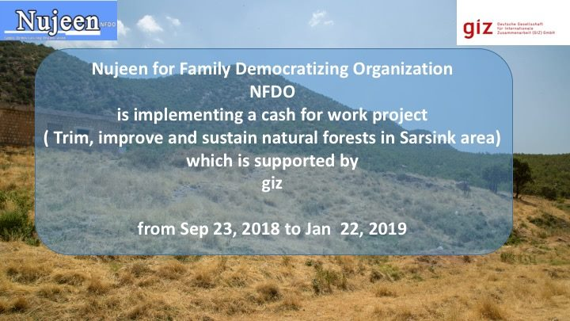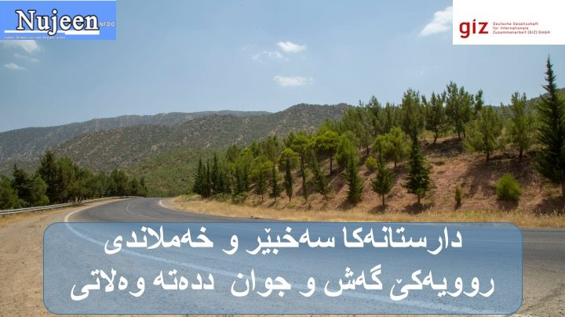
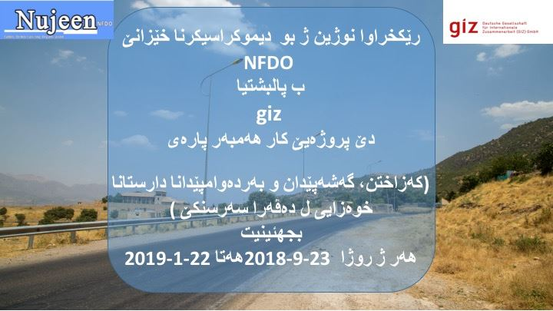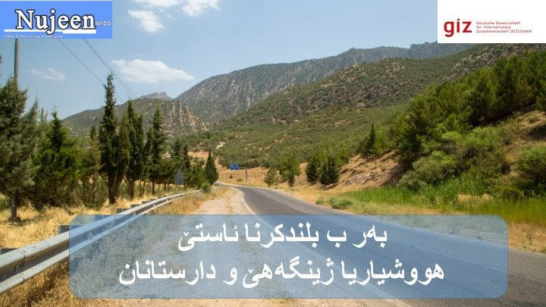
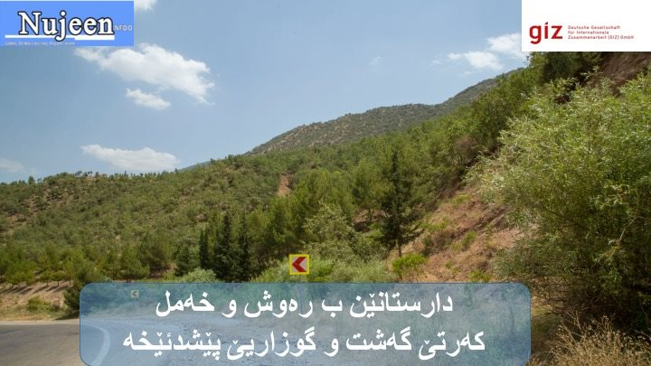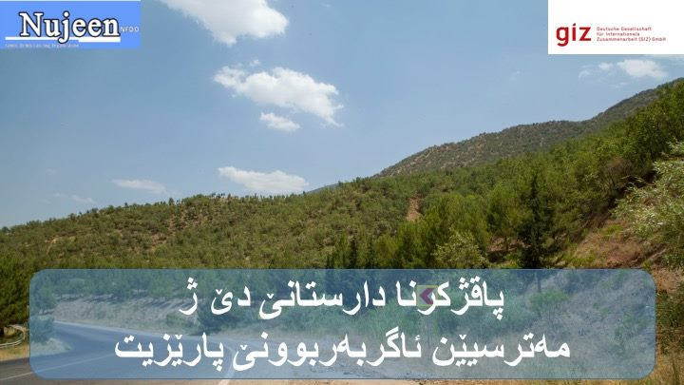

Below are the links of the TV reports on the opening day of the project.
- https://www.dengeamerika.com/a/proj%C3%AA-parastina-j%C3%AEngeh%C3%AA-li-duhok-%C3%AA/4667929.html?fbclid=IwAR0M-5Zqm0RErRJgrgrAPSSaIuyOAf_TwWnjdUzspRcgbULft6O3a7OXwJw
- http://www.nujeen.org/blog/opening-ceremony-trim-improve-and-sustain-natural-forest-sarsink-area

Contact information
Norjan Mustafa  Project Manager |  | Muhammad Jano  Finance Manager |  |  | Jeen Azad  Monitoring& Evaluation officer |  | Dijwar Sadiq  Field Coordinator
Tel 07507621055  E: normustafa@gmail.com |  |  | Tel 07504572326  E:m_canob@yahoo.com |  |  | Tel 07515265611  E:Jeen.ay99@gmail.com | Tel: 07504921795  E:dijwar@nujeen.org

